| **SCHOOL OF SCIENCES AND HUMANITIES** | | | **DEPARTMENT OF BASIC SCIENCES** | | |
| --- | --- | --- | --- | --- | --- |
| **Program Name:** B. Tech. | | **Assignment Type: Lab** | | | **Academic Year:** 2025-26 |
| **Name** | | **Gandra Bala Aditya Reddy** | | | |
| **Hall Ticket No** | | **2503A51226** | | | |
| **Course Code** | 25SCI202BS106 | **Course Title** | | Computational chemistry and biology | |
| **Year/Sem** | I/I | **Regulation** | | R25 | |
| **Date and Day**  **of Assignment** | 08/09/25 | **Time(s)** | | 1-3 pm | |
| **Duration** | 2 Hours | **Applicable to**  **Batches** | | All Batch CSE | |
| **Assignment Number: 04/12** | | | | | |

**Molecule docking**

**Problem:**

A Computational Drug Discovery team has designed a novel inhibitor predicted to bind to a key target protein. Before committing to expensive wet-lab experiments, they require computational validation of the binding interaction and stability using molecular docking and analysis. The analysis demands:

* Prediction of viable binding poses and identification of conformational changes.
* Detection and visualization of key interactions, particularly hydrogen bonds.
* Quantifiable structural metrics of the complex, including RMSD, RMSF, and radius of gyration.

**Aim:**

To characterize the Cyclooxygenase-2–Ibuprofen complex to validate its binding interaction and structural stability using only free/open-source software.

**Objective:**

Identify critical properties for characterization, including:

* Predicted binding pose and conformation of Ibuprofen within the COX-2 active site.
* Binding affinity (docking score) for the most favorable poses.
* Key intermolecular interactions (e.g., hydrogen bonds, hydrophobic contacts).

Select appropriate free/open-source tools and justify their choice:

* UCSF ChimeraX for protein preparation and visualization.
* PubChem for sourcing the ligand structure.
* A web-based server like CB-Dock2 or SwissDock for performing the docking simulation.

Design a docking workflow, including:

* Preparation of the protein (receptor) by removing water and heteroatoms.
* Preparation of the ligand in the correct 3D format (Mol2).
* Definition of the binding site (search space).
* Execution of the docking algorithm.

Analyze results and present them in a short discovery report, stating whether the predicted binding of Ibuprofen to Cyclooxygenase-2 is computationally validated and consistent with its known mechanism of action.

**Procedure:**

1. Retrieve the 3D crystal structure of **Cyclooxygenase-2** (e.g., **PDB ID: 1PXX**) from the **RCSB Protein Data Bank.**
2. Obtain the 3D structure of the **Ibuprofen** ligand from the **PubChem database** and convert it to the required file format (Mol2).
3. **Prepare** the protein structure by **removing all non-essential molecules**, including water, cofactors (Heme), and sugars (NAG), using UCSF ChimeraX.
4. **Upload** the **prepared protein** (receptor) and ligand files to a web-based docking server like CB-Dock2.
5. Define the **binding site** by allowing the server to **automatically detect** the most probable cavities.
6. **Execute** the **molecular docking simulation** to predict the binding poses of **Ibuprofen** within the active sites of **COX-2**.
7. **Analyze** the results provided by the server, focusing on the top-ranked poses with the best **docking scores** (binding affinities).
8. **Visualize** the highest-scoring protein-ligand complex to identify key intermolecular interactions, such as hydrogen bonds and hydrophobic contacts.
9. Generate images and a summary of the binding interactions to validate the computational model against the known mechanism of action.

**Results and solutions to the problem:**

**PDB ID**: 1PXX (Mouse Cyclooxygenase-2)

**Ligand**: Ibuprofen

**Docking Success**: The docking simulation successfully completed, identifying five potential binding cavities (pockets) and predicting the binding affinity of Ibuprofen in each.

**Top Result**: The best binding pose was found in Cavity 4 (C4), which achieved the most favorable Vina Score of -7.7 (kcal/mol), indicating a strong predicted binding affinity.

**Binding Site**: Analysis of the results page shows that the top-ranked cavities (C1, C2, C4, C5) are all located within the main channel of the enzyme, which is the known active site for inhibitor binding.

**Key Interactions**: The final docked complex shows Ibuprofen fitting snugly within the binding pocket, positioned to form key stabilizing interactions with the surrounding amino acid residues, consistent with its mechanism of action as a COX-2 inhibitor.

**Outcome:**

**Template Based Cavity Detection**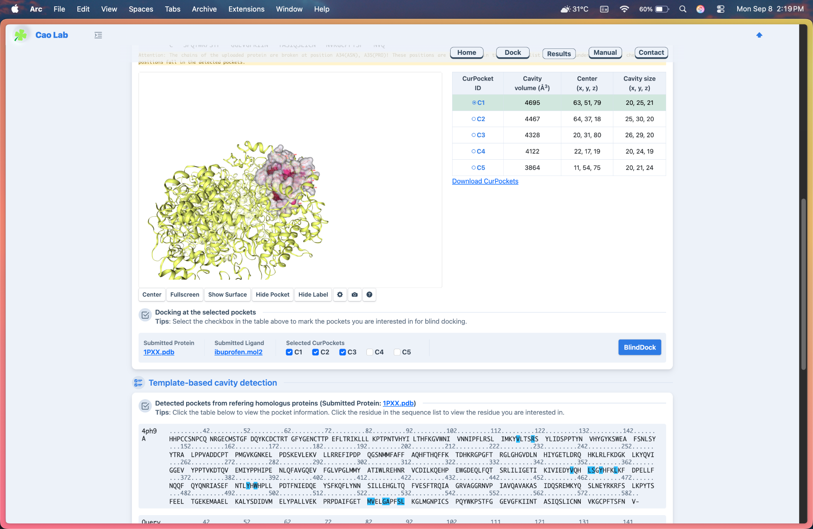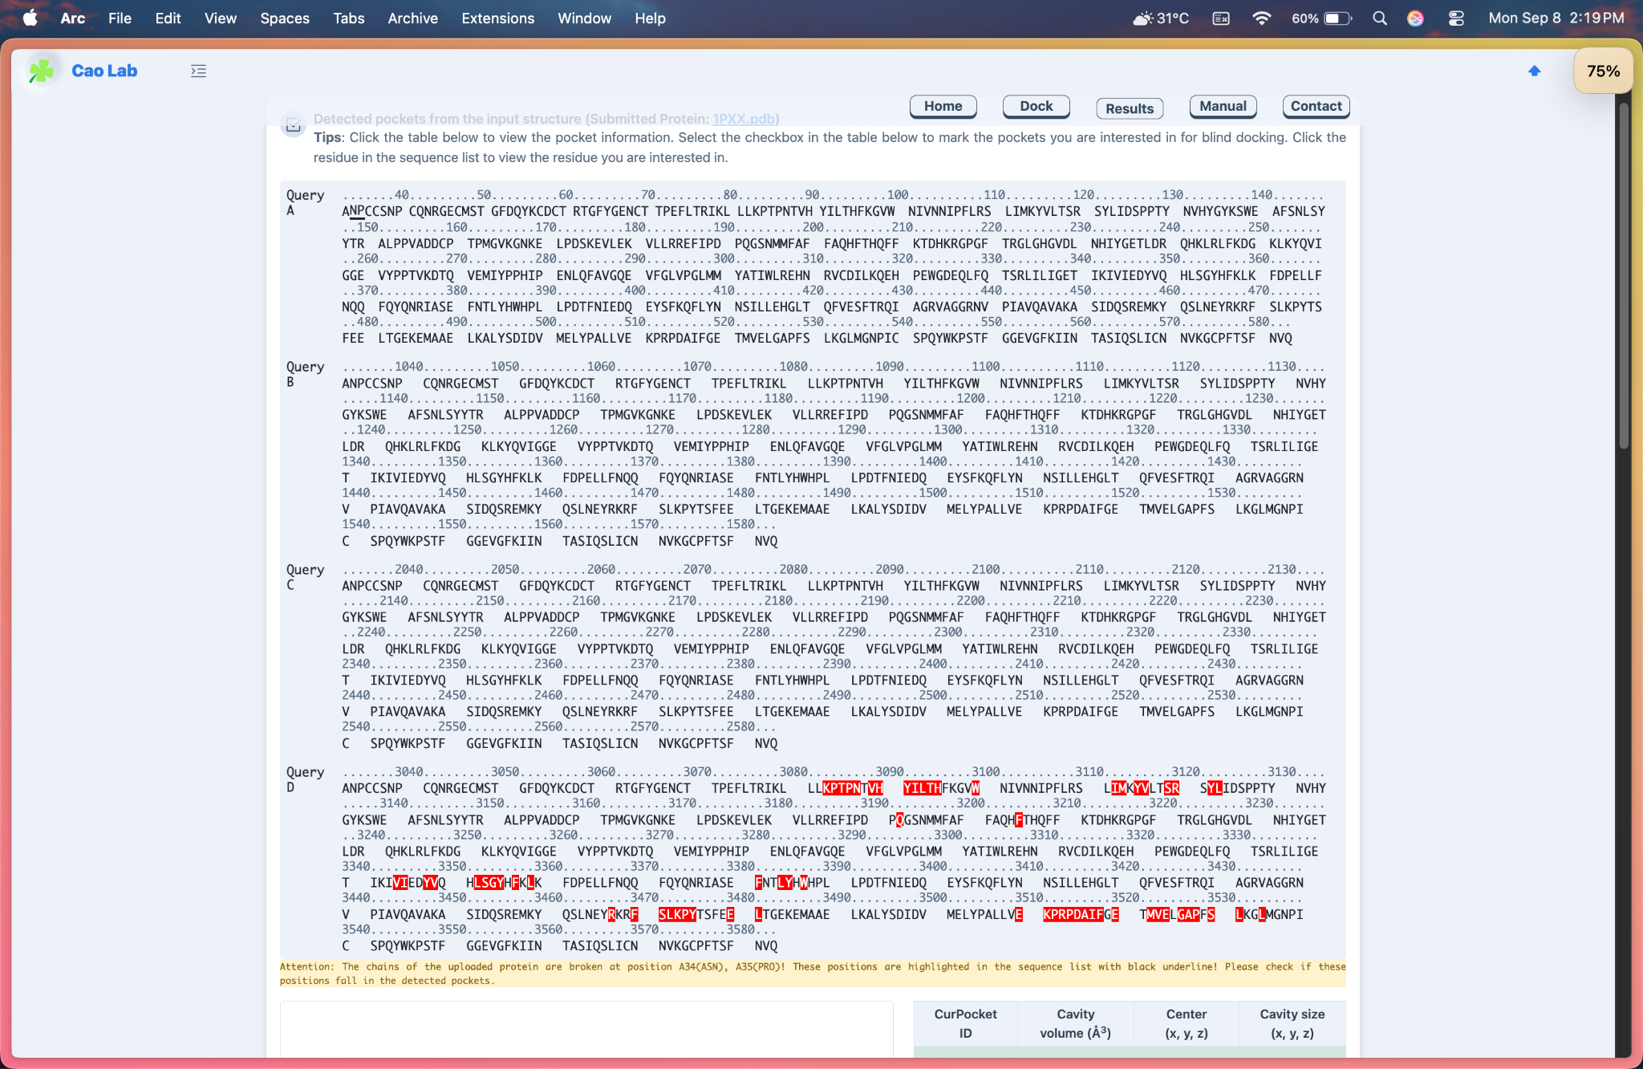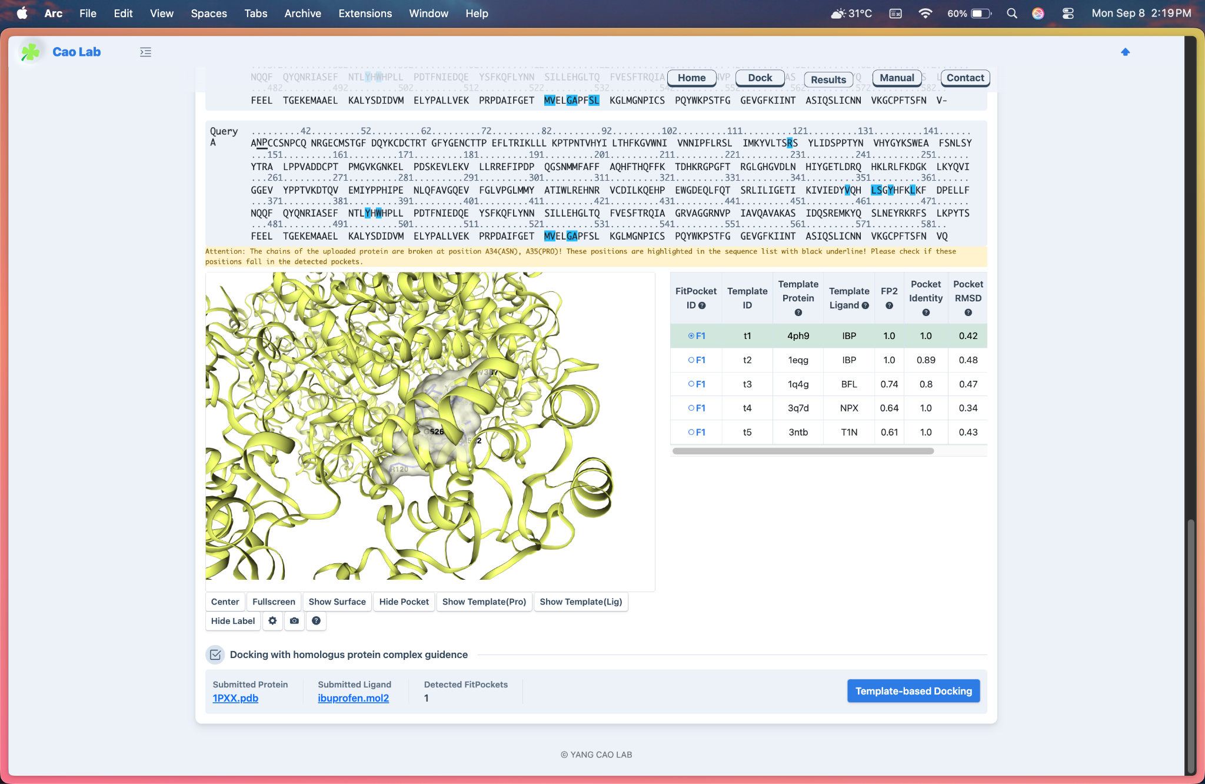

**Structure Based Ligand Docking**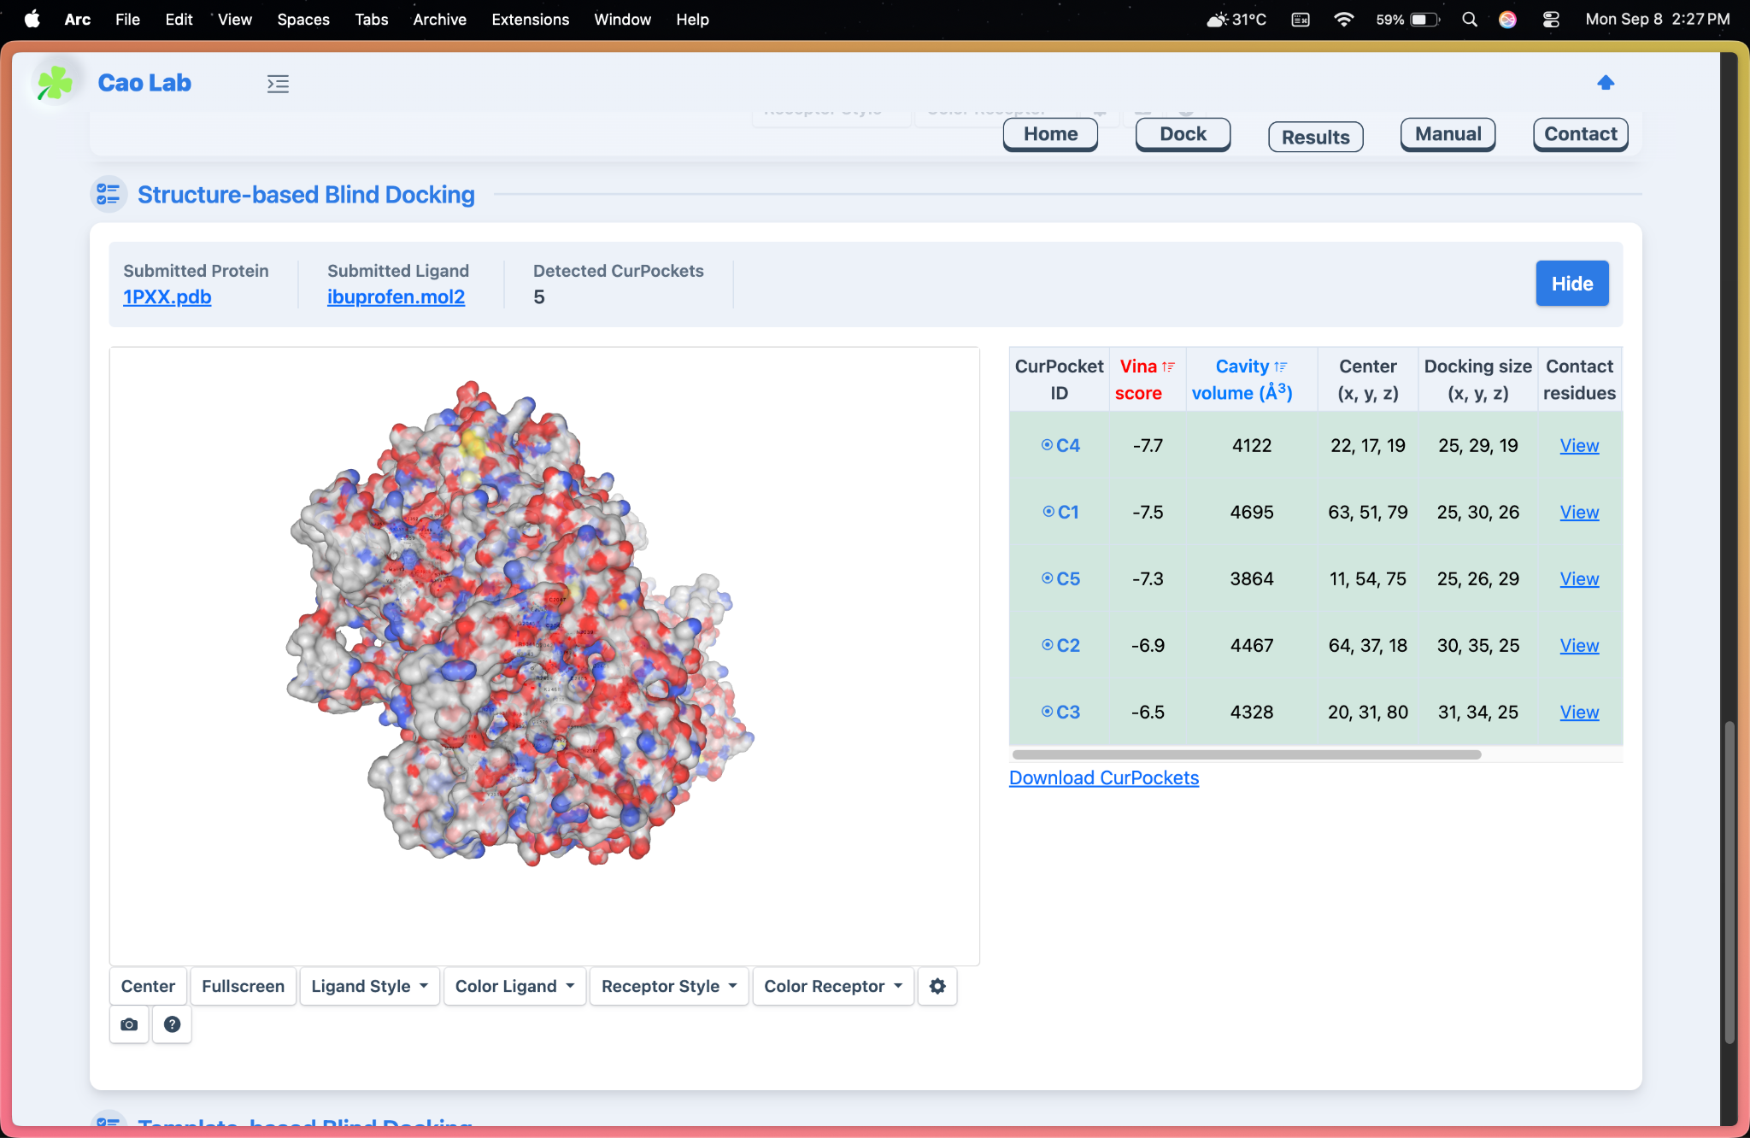

**Template Based Blind Docking**

